IFT 554: Middleware Programming & Database Security

Rajesh Kumar

Module 7 Lab 2

Dinesh Sthapit

November 19th, 2023

# **Module 7 Lab 2: HTTP Status/Error**

**Setting Up:**

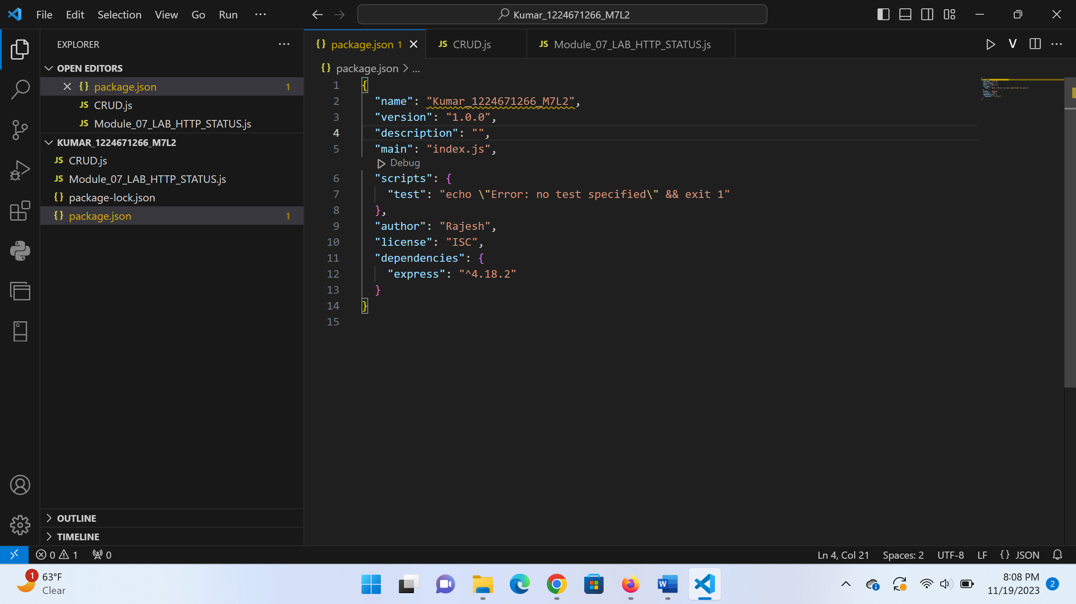

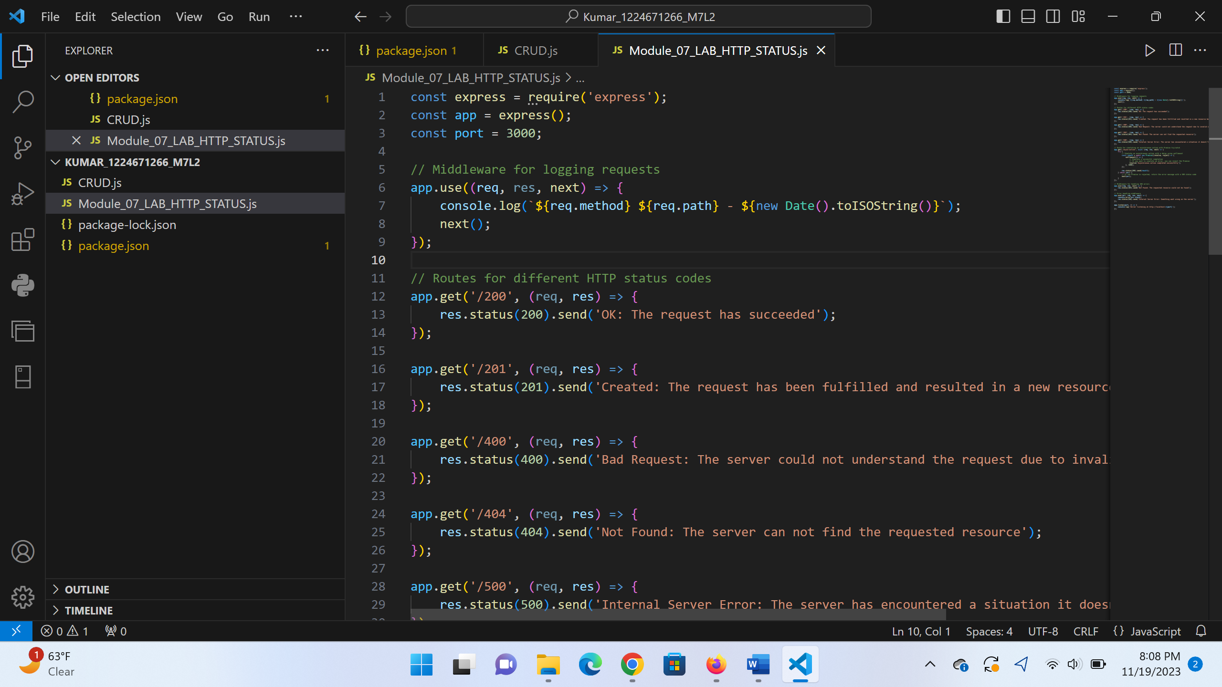

Code:

const express = require('express');

const app = express();

const port = 3000;

// Middleware for logging requests

app.use((req, res, next) => {

    console.log(`${req.method} ${req.path} - ${new Date().toISOString()}`);

    next();

});

// Routes for different HTTP status codes

app.get('/200', (req, res) => {

    res.status(200).send('OK: The request has succeeded');

});

app.get('/201', (req, res) => {

    res.status(201).send('Created: The request has been fulfilled and resulted in a new resource being created');

});

app.get('/400', (req, res) => {

    res.status(400).send('Bad Request: The server could not understand the request due to invalid syntax');

});

app.get('/404', (req, res) => {

    res.status(404).send('Not Found: The server can not find the requested resource');

});

app.get('/500', (req, res) => {

    res.status(500).send('Internal Server Error: The server has encountered a situation it doesn\'t know how to handle');

});

// Route for simulating an asynchronous action with Promise try/catch

app.get('/async-action', async (req, res, next) => {

    try {

        // Simulate an asynchronous action with a delay using setTimeout

        const result = await new Promise((resolve, reject) => {

            setTimeout(() => {

                // Simulate a successful completion

                // If you want to simulate an error, you can reject the Promise

                resolve('Asynchronous action completed successfully');

            }, 1000);

        });

        res.status(200).send(result);

    } catch (err) {

        // If the Promise is rejected, return the error message with a 500 status code

        next(err);

    }

});

// Middleware for handling 404 errors

app.use((req, res, next) => {

    res.status(404).send('Not Found: The requested resource could not be found');

});

// Error handling middleware

app.use((err, req, res, next) => {

    console.error(err.stack);

    res.status(500).send('Internal Server Error: Something went wrong on the server');

});

app.listen(port, () => {

    console.log(`Server listening at http://localhost:${port}`);

});

Output:

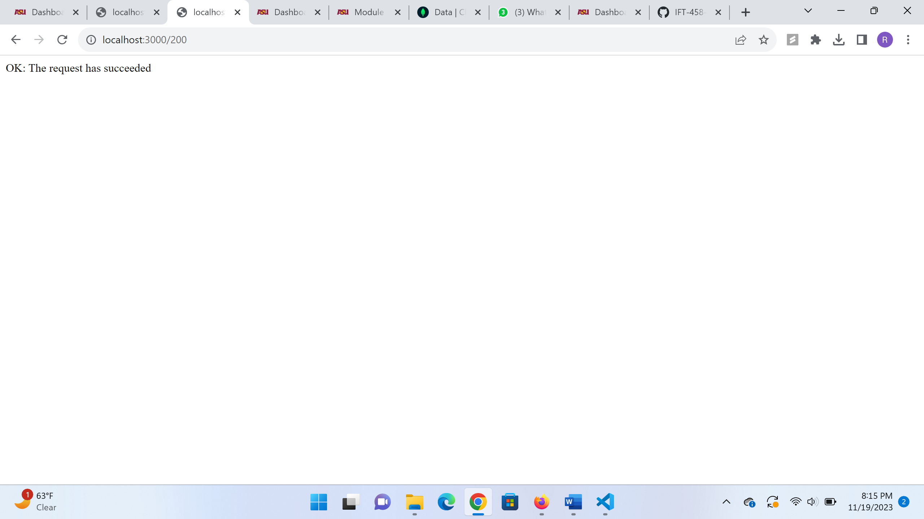

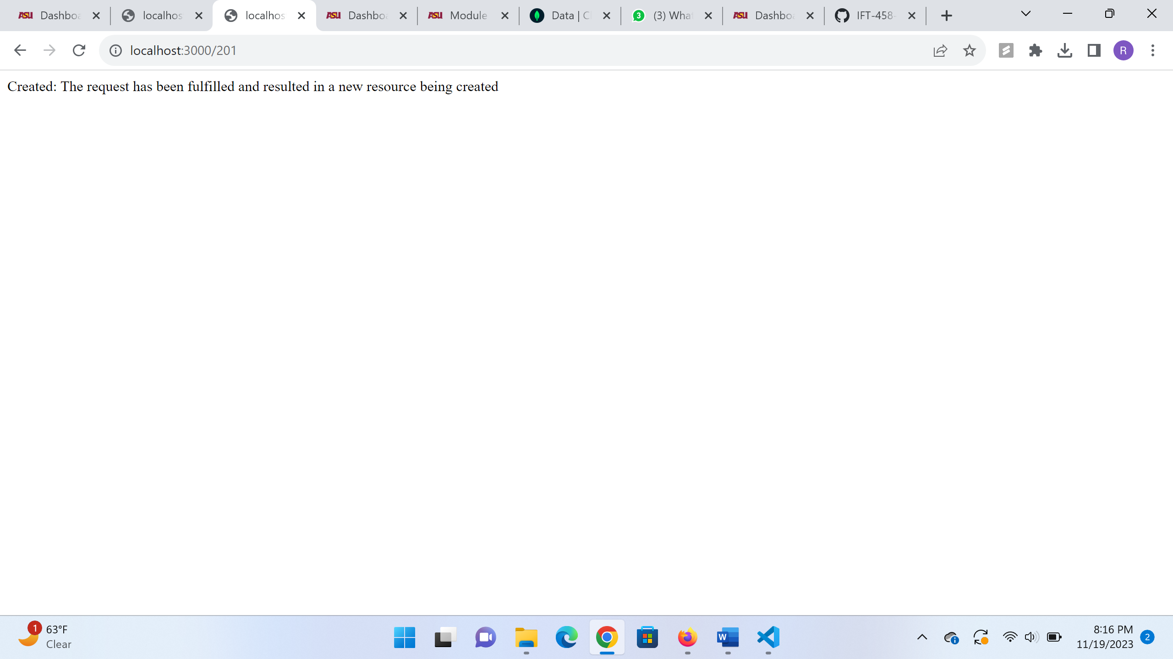

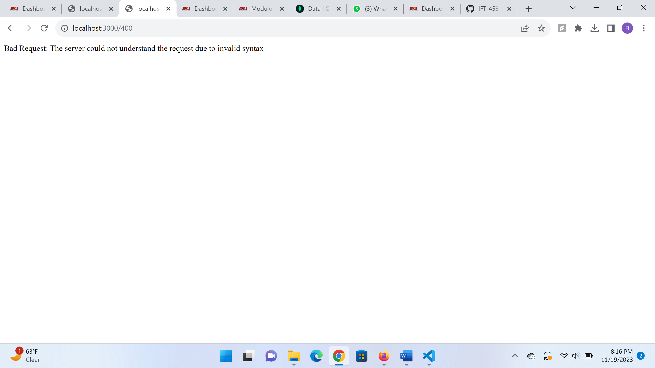

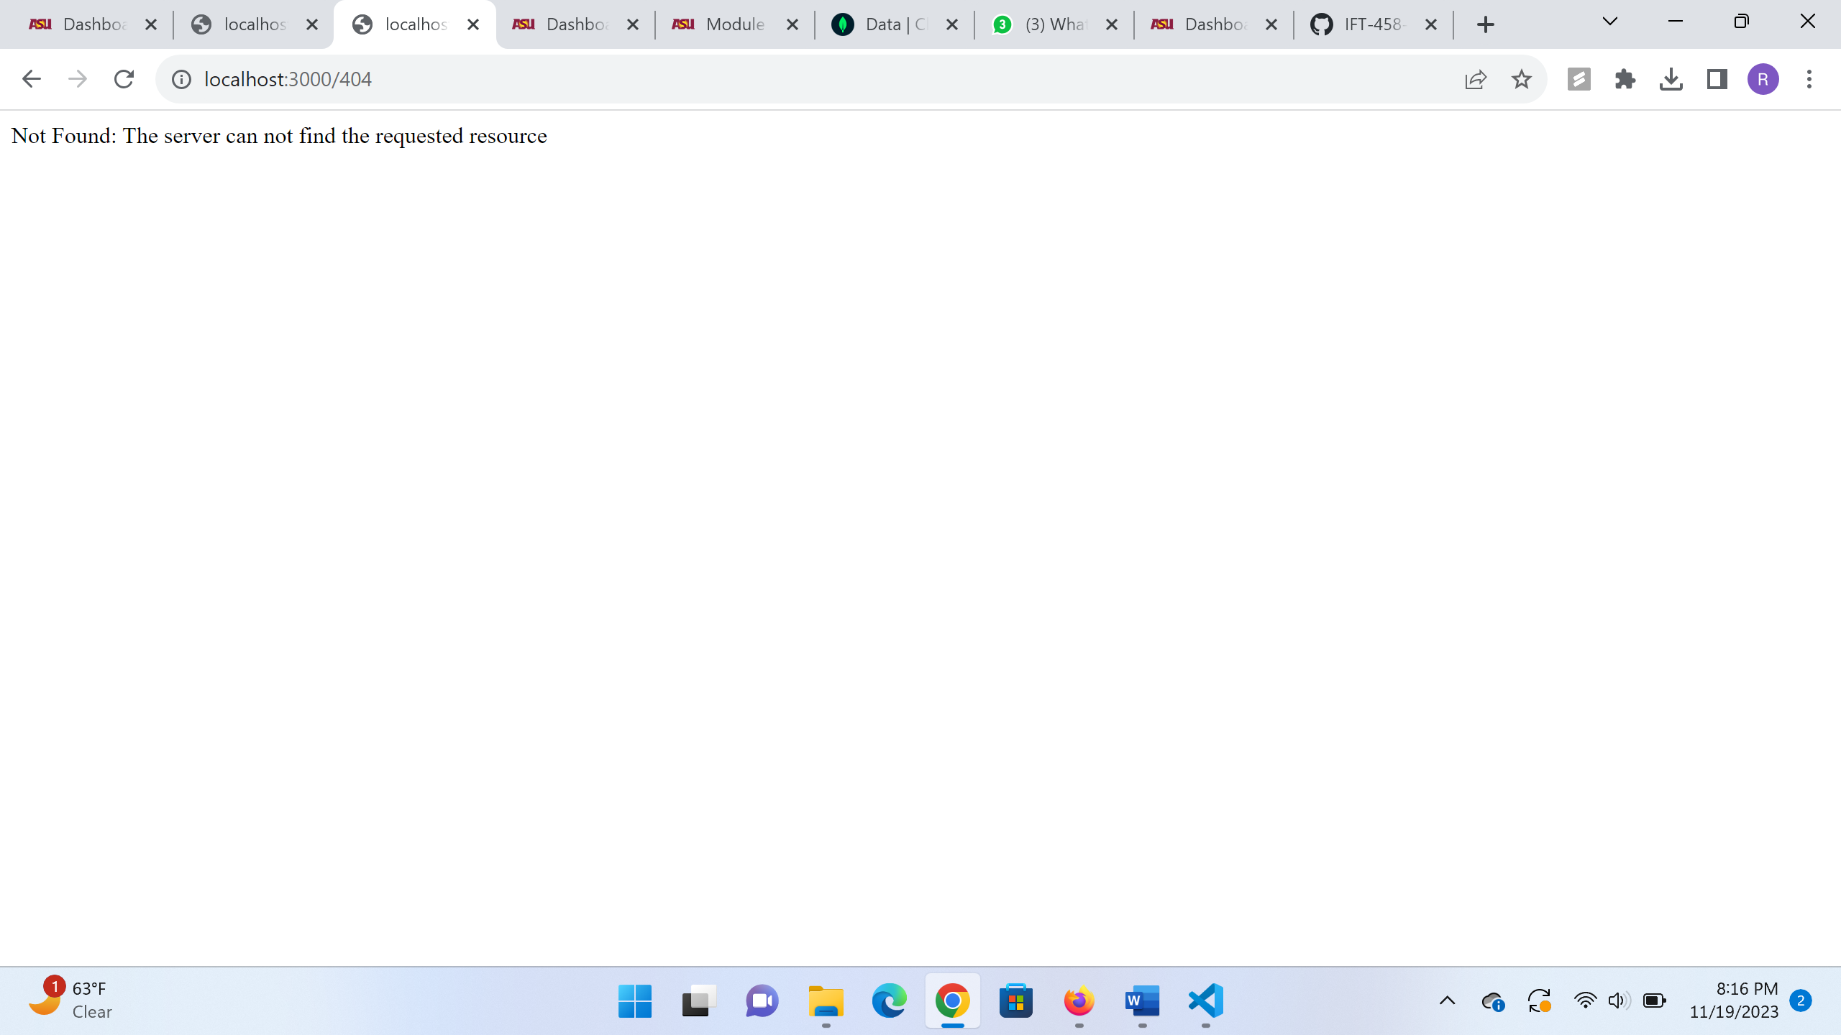

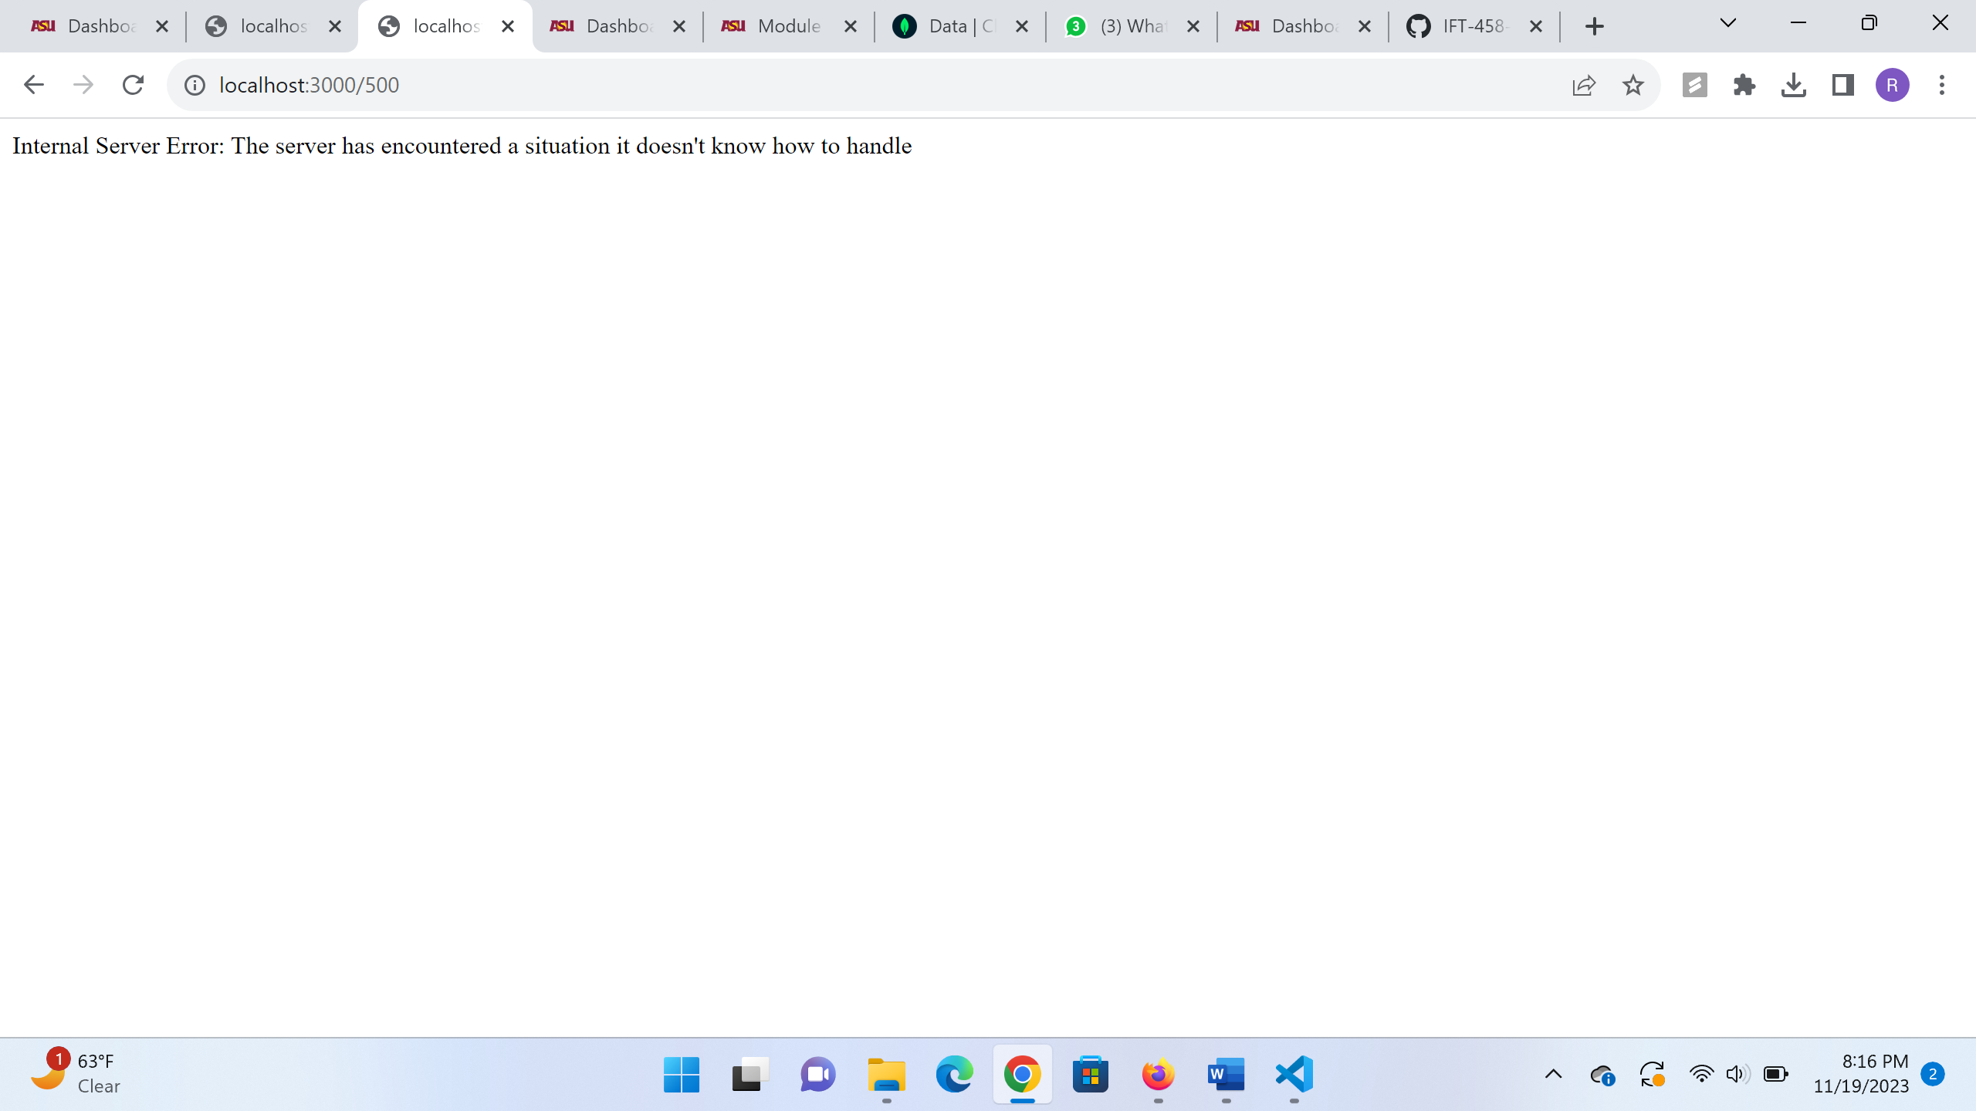

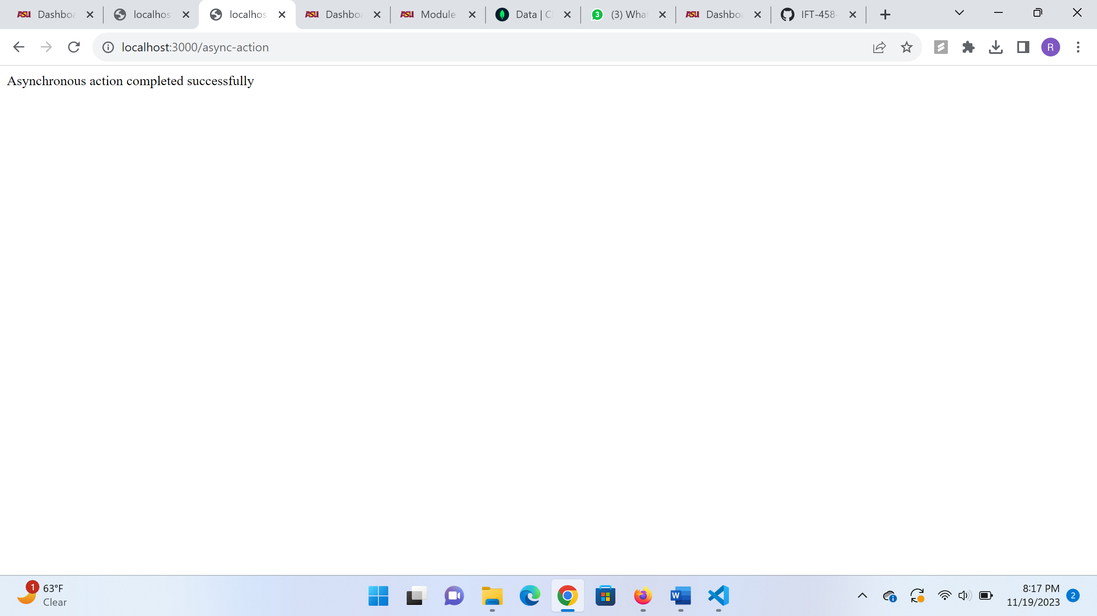

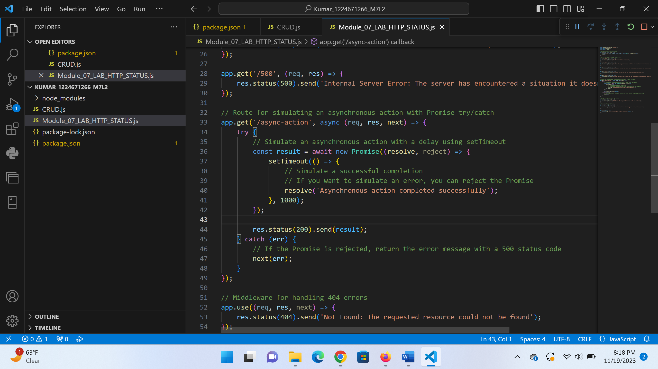

**PART 2 CRUDS Operations:**

CRUD.js

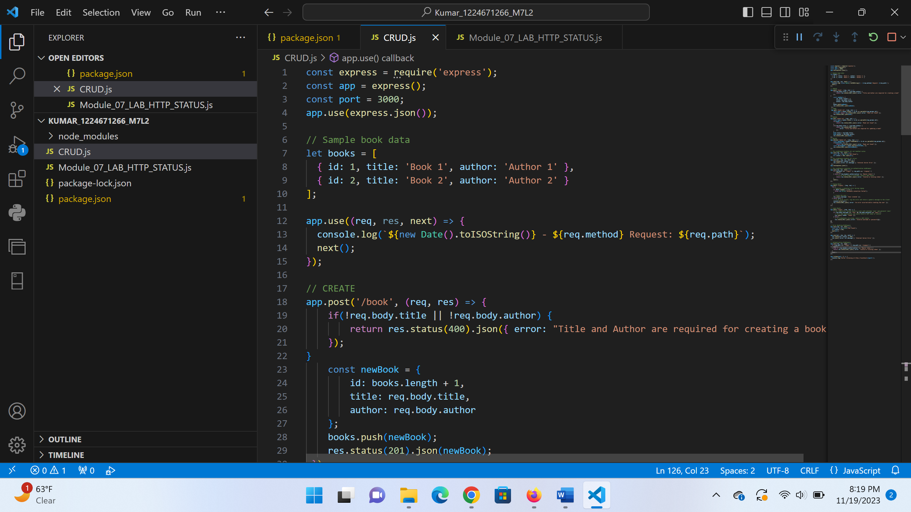

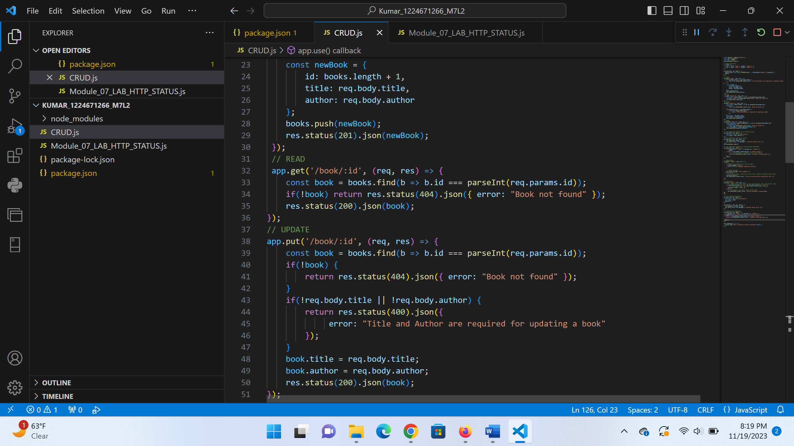

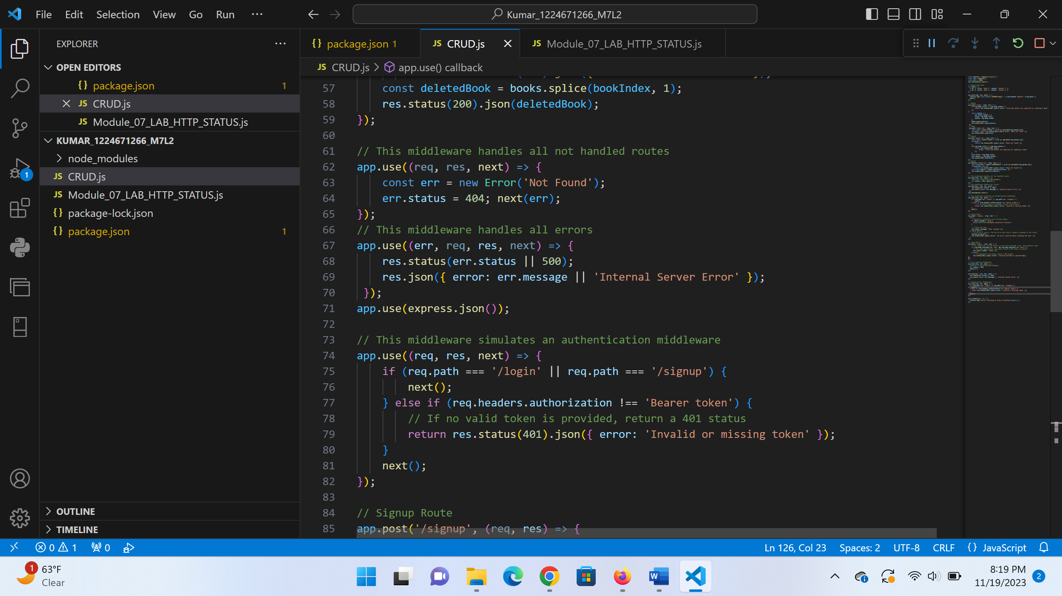

const express = require('express');

const app = express();

const port = 3000;

app.use(express.json());

// Sample book data

let books = [

  { id: 1, title: 'Book 1', author: 'Author 1' },

  { id: 2, title: 'Book 2', author: 'Author 2' }

];

app.use((req, res, next) => {

  console.log(`${new Date().toISOString()} - ${req.method} Request: ${req.path}`);

  next();

});

// CREATE

app.post('/book', (req, res) => {

    if(!req.body.title || !req.body.author) {

        return res.status(400).json({ error: "Title and Author are required for creating a book"

    });

}

    const newBook = {

        id: books.length + 1,

        title: req.body.title,

        author: req.body.author

    };

    books.push(newBook);

    res.status(201).json(newBook);

 });

 // READ

 app.get('/book/:id', (req, res) => {

    const book = books.find(b => b.id === parseInt(req.params.id));

    if(!book) return res.status(404).json({ error: "Book not found" });

    res.status(200).json(book);

});

// UPDATE

app.put('/book/:id', (req, res) => {

    const book = books.find(b => b.id === parseInt(req.params.id));

    if(!book) {

        return res.status(404).json({ error: "Book not found" });

    }

    if(!req.body.title || !req.body.author) {

        return res.status(400).json({

             error: "Title and Author are required for updating a book"

        });

    }

    book.title = req.body.title;

    book.author = req.body.author;

    res.status(200).json(book);

});

// DELETE

app.delete('/book/:id', (req, res) => {

    const bookIndex = books.findIndex(b => b.id === parseInt(req.params.id));

    if(bookIndex === -1)

        return res.status(404).json({ error: "Book not found" });

    const deletedBook = books.splice(bookIndex, 1);

    res.status(200).json(deletedBook);

});

// This middleware handles all not handled routes

app.use((req, res, next) => {

    const err = new Error('Not Found');

    err.status = 404; next(err);

});

// This middleware handles all errors

app.use((err, req, res, next) => {

    res.status(err.status || 500);

    res.json({ error: err.message || 'Internal Server Error' });

 });

app.use(express.json());

// This middleware simulates an authentication middleware

app.use((req, res, next) => {

    if (req.path === '/login' || req.path === '/signup') {

        next();

    } else if (req.headers.authorization !== 'Bearer token') {

        // If no valid token is provided, return a 401 status

        return res.status(401).json({ error: 'Invalid or missing token' });

    }

    next();

});

// Signup Route

app.post('/signup', (req, res) => {

  try {

    // Simulate a potential error during signup

    if (Math.random() < 0.5) {

      throw new Error('Database connection failed');

    }

    // Create the user...

    res.json({ message: 'User created' });

  } catch (err) {

    // If an error occurs, log the error and return a generic message to the client

    console.error(err);

    res.status(500).json({ error: 'An error occurred while creating the user' });

  }

});

// Login Route

app.post('/login', (req, res) => {

    // For simplicity, assume there's a user with username 'user' and password 'pass'

    if (req.body.username === 'user' && req.body.password === 'pass') {

      // In a real application, you would return a JWT token or similar

      res.json({ token: 'token' });

    } else {

      // If credentials are wrong, return a 401 status

      res.status(401).json({ error: 'Invalid username or password' });

 }

});

// Error Handling Middleware

app.use((req, res, next) => {

  const err = new Error('Not Found');

  err.status = 404;

  next(err);

});

app.use((err, req, res, next) => {

  res.status(err.status || 500);

  res.json({ error: err.message || 'Internal Server Error' });

});

// Authentication Middleware

app.use((req, res, next) => {

  if (req.path === '/login' || req.path === '/signup') {

    next();

  } else if (req.headers.authorization !== 'Bearer token') {

    return res.status(401).json({ error: 'Invalid or missing token' });

  }

  next();

});

app.listen(port, () => {

  console.log(`Server listening at http://localhost:${port}`);

});

Running

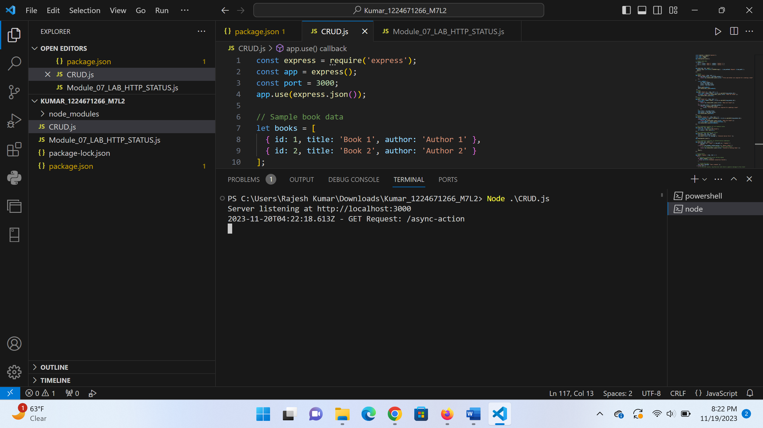

Post:

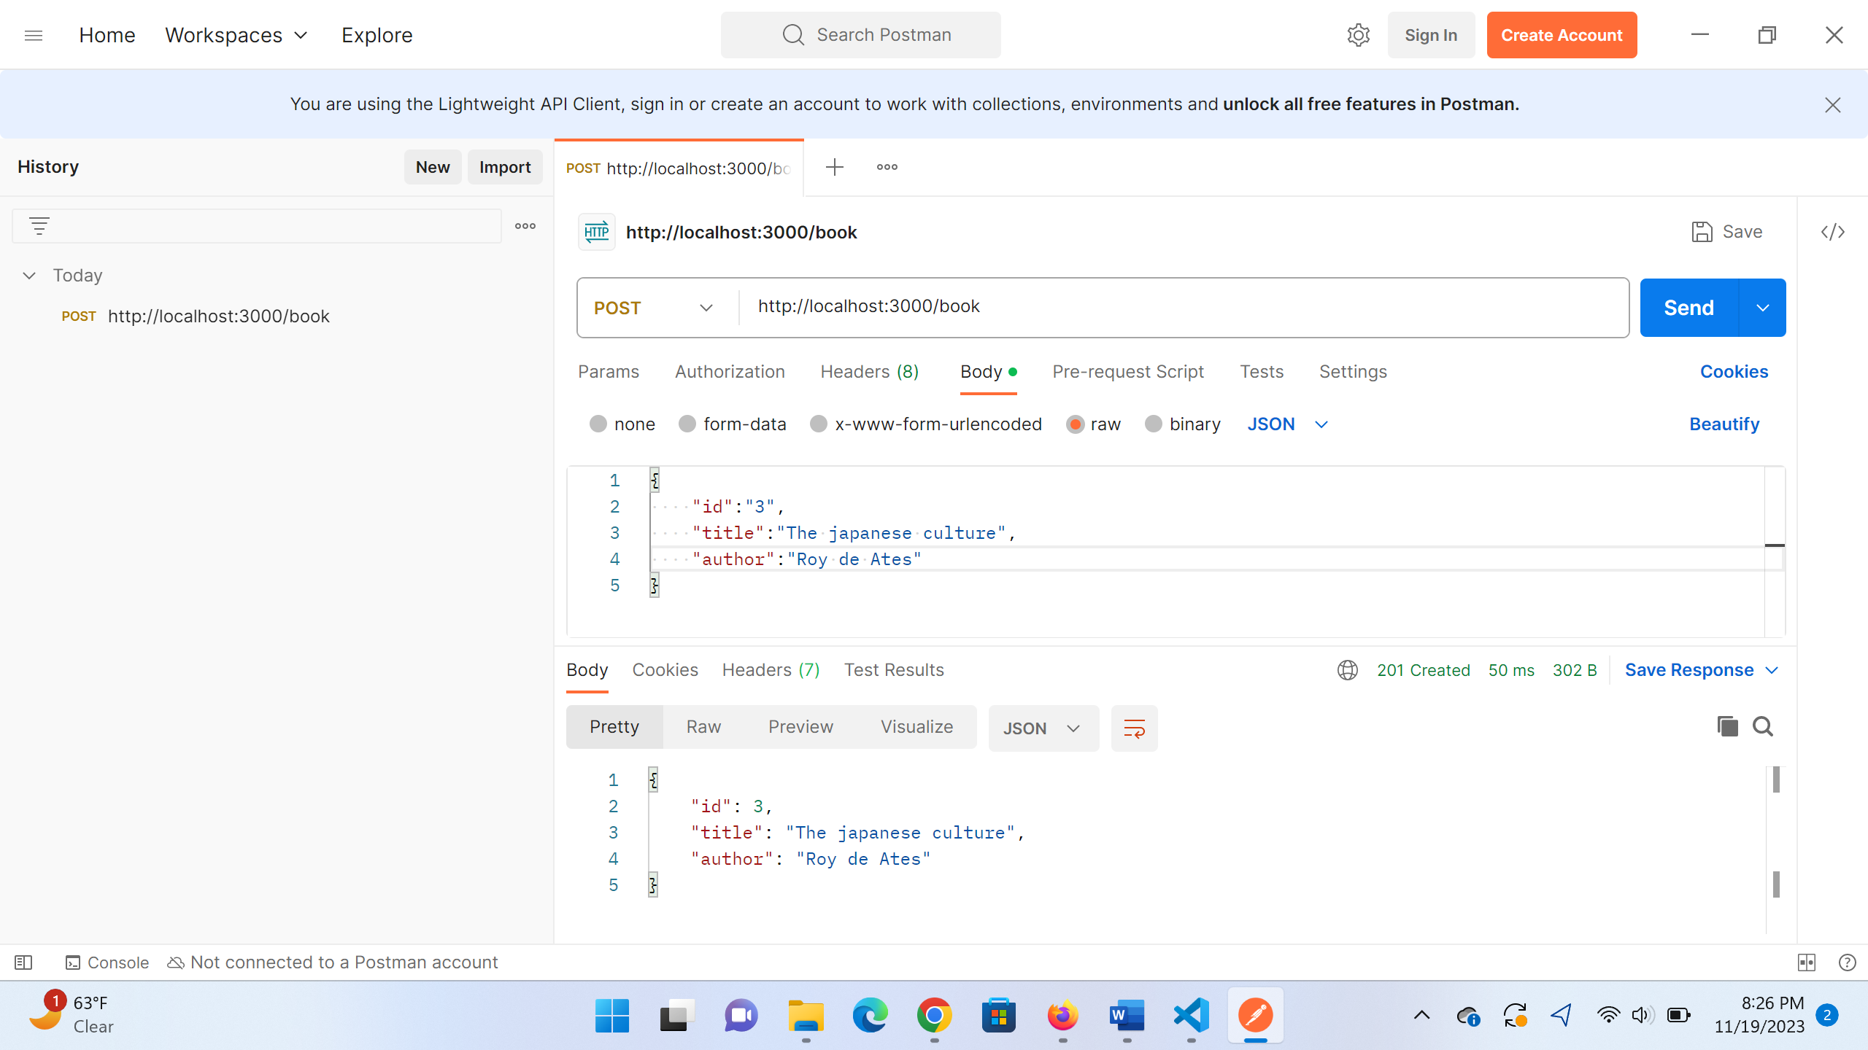

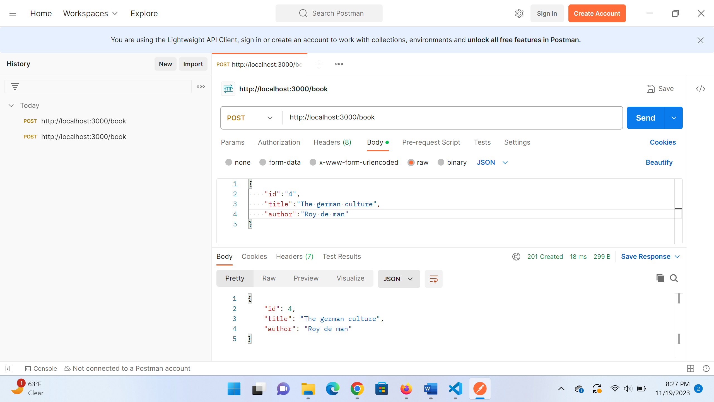

Get by ID:

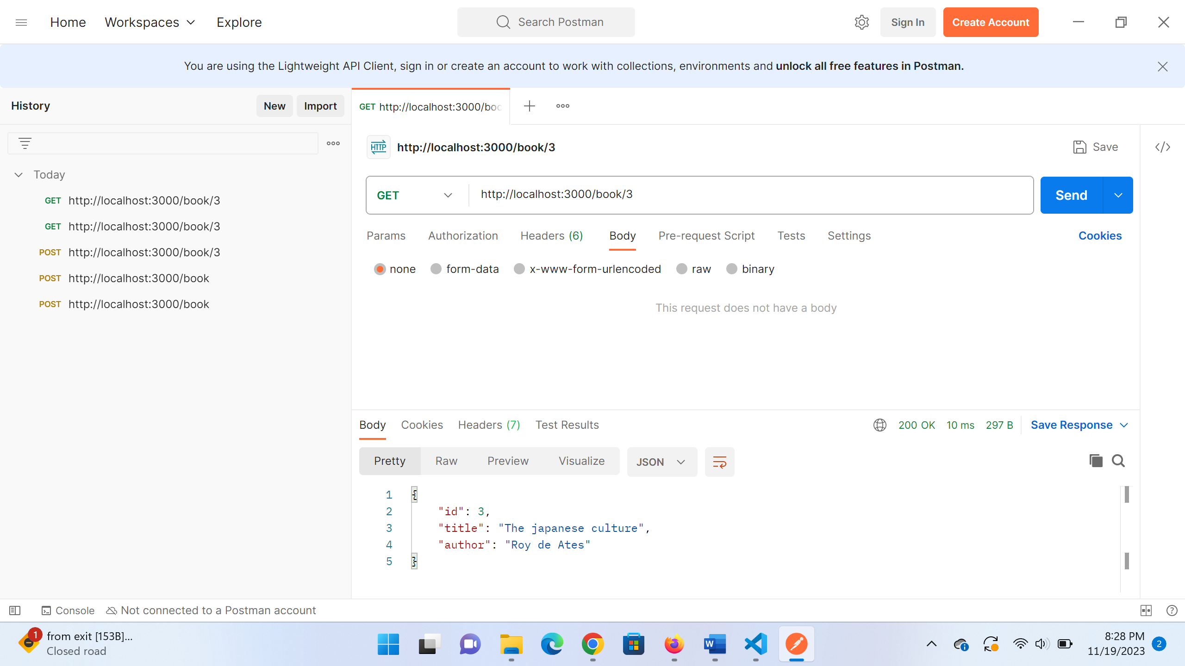

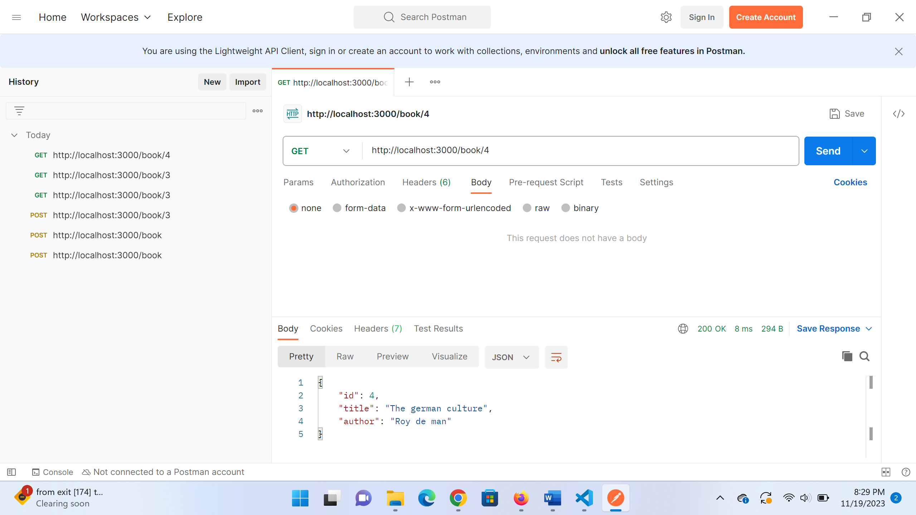

Put:

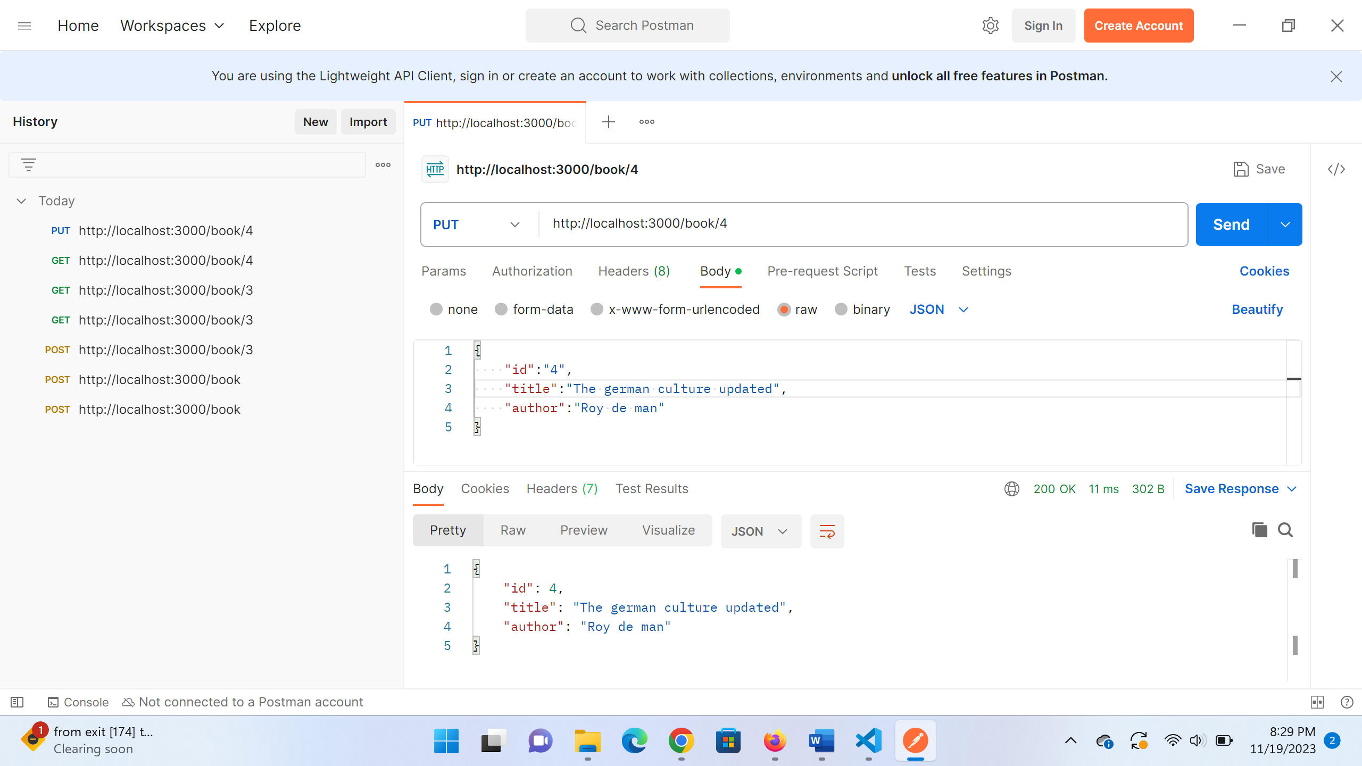

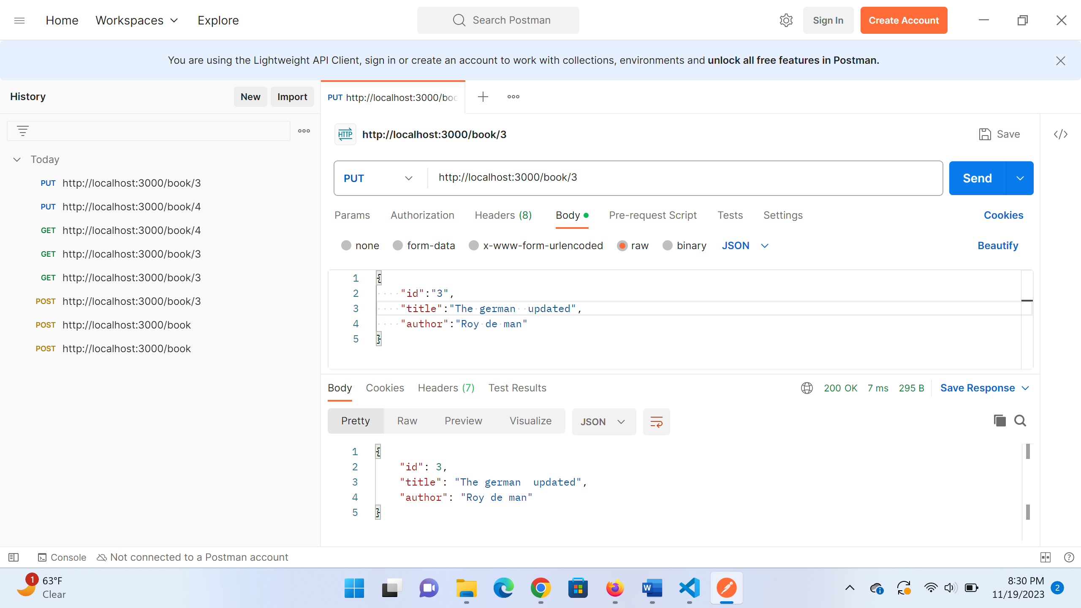

Delete:

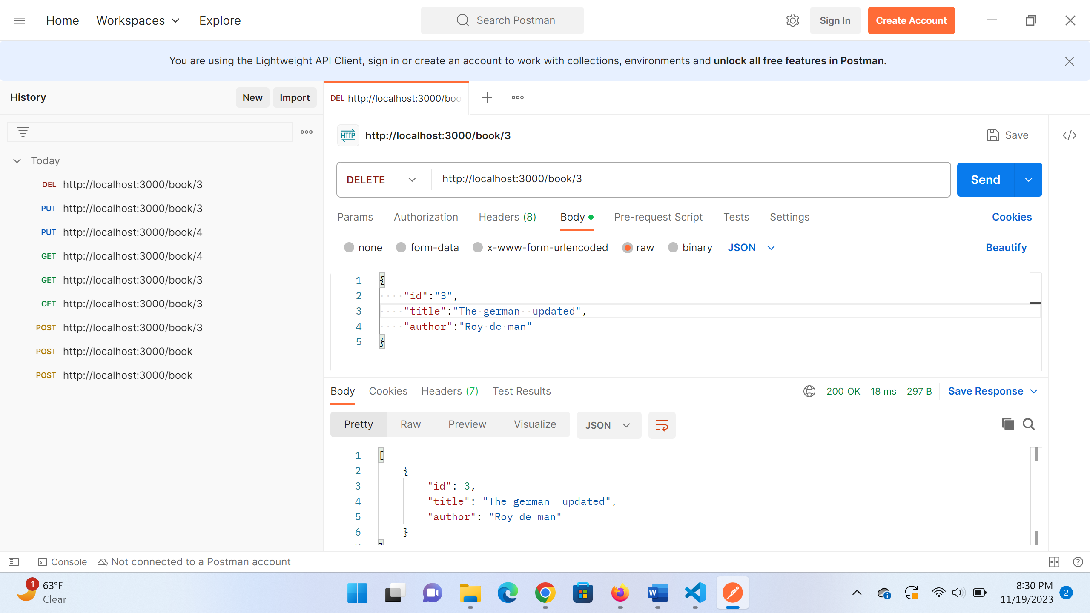

After deleting book 3

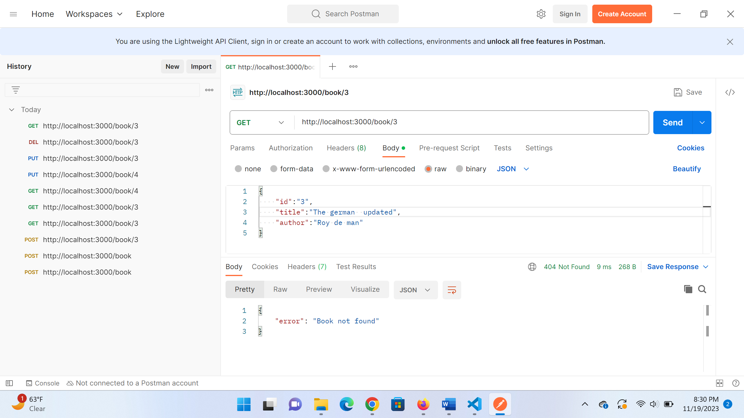

**POST Creating user**

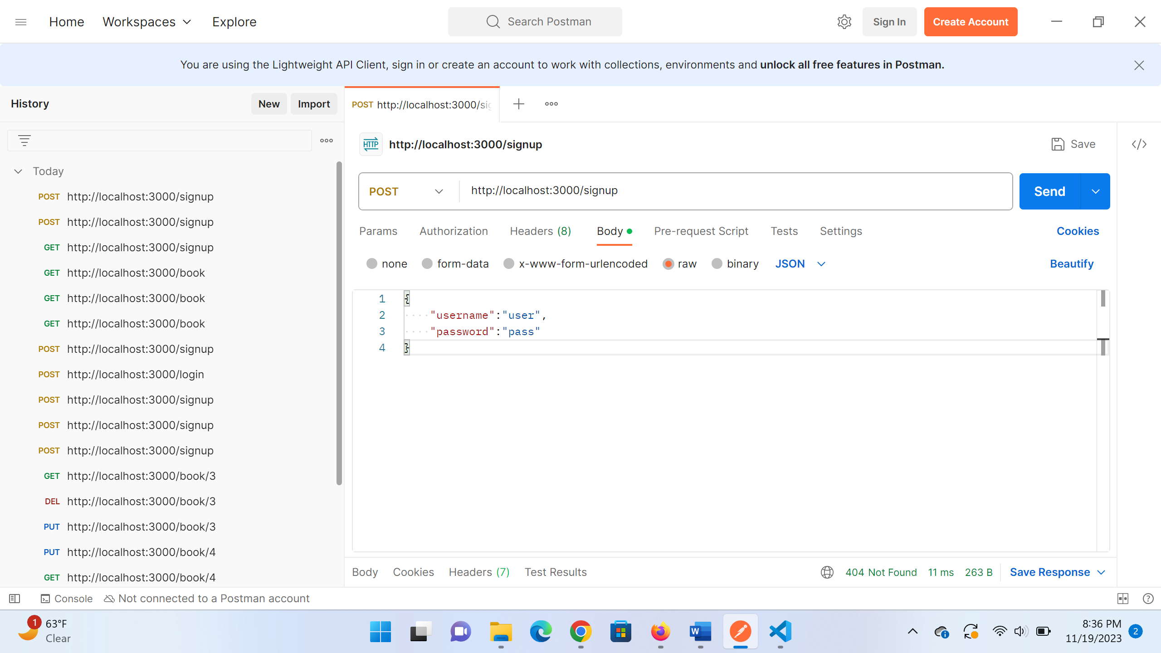

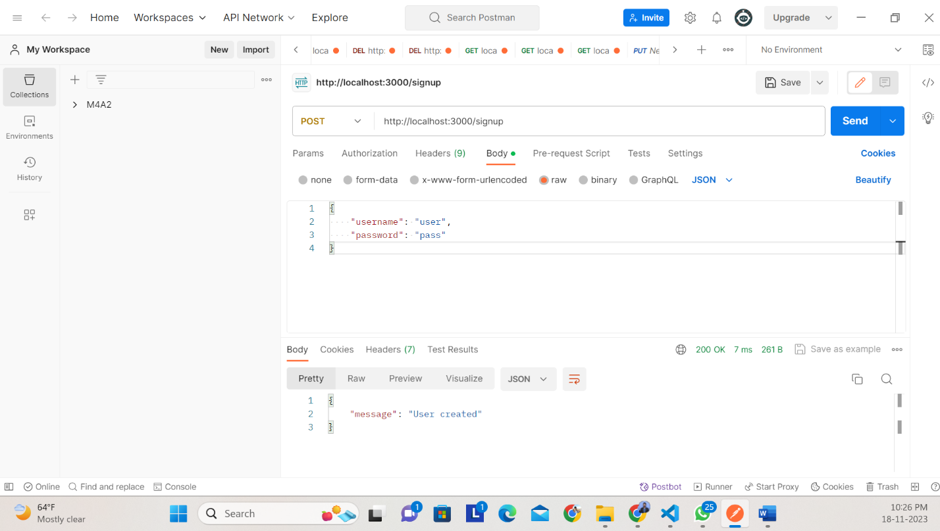

**POST: Login by creating a Token:**

